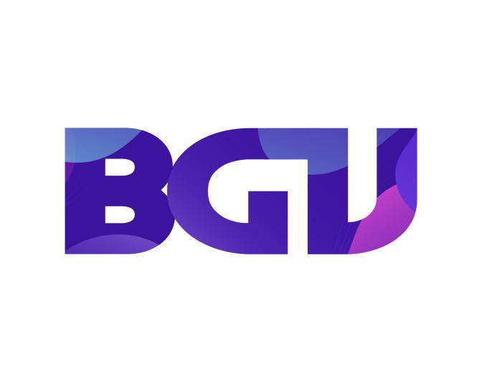

**INFORMATION TECHNOLOGY**

**1. Introduction**

According to research in the world:

-91% of children with computer skills have a higher IQ than other kids.

- 83% of children have access to information from a very young age

-75% students do well in informatics and learn well other subjects

Knowing that, BGV Academy will equip students with basic to advanced knowledge about informatics.

**2/Class time :**

* Basic class: 3 months (4 times/week)
* Advanced class: 4 months (4 times/week)

**3/The content of the course :**

**Basic class:**

10-finger typing skills

Computer skills

- 1. Basic information technology

- 2. Windows operating system and applications

- 3. Internet

Microsoft Paint

**Advanced class:**

MSW Logo

Microsoft Word 2010.

Microsoft PowerPoint

Microsoft Excel 2010

**4/The tuition fees of the courses are as follows :**

- For Basic Classes: The course lasts 3 months with tuition of 900$ and we are committed to the best teaching quality for the children.

- For Advanced Classes: The course lasts 4-month course with a cost of 1500$, we are committed to the best teaching quality for our children.